Using Edge Caregiver Portal and Mobile App

Access to the edge caregiver portal and mobile app uses the existing email address that your school has on record.

The edge caregiver portal/app allows you to view school information about your child(ren), and to pay school bills online if your school supports this. The portal & app gives you quick and easy access to the information for the children in your care as well as being able to receive announcements and notifications from the school.

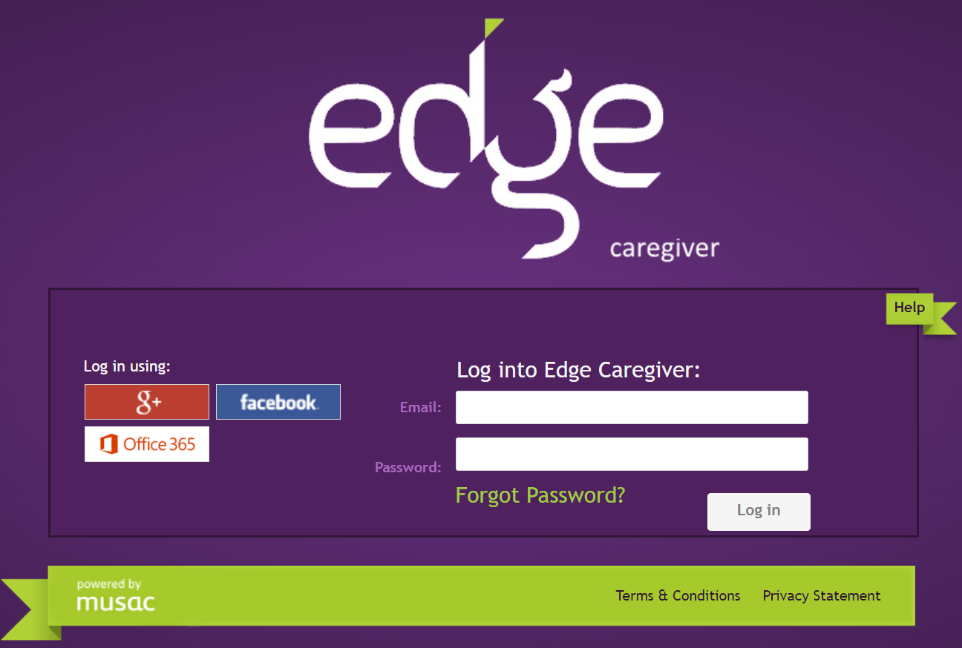

To login:
- Enter the website https://parent.edgelearning.co.nz/ into your browser.
- Either:
  - click the icon (either g+ for Google, Facebook or Office 365), that is associated with the email you have supplied to your school. A popup will appear asking for your login details. On entering this correctly the Edge caregiver home page opens, or
  - if your email is not associated with the three above (they are all free, easy to sign up to and don’t necessitate you using that email for other purposes), type in the email address you supplied to the school. You will then be asked to supply a password. Choose the ‘Forgot Password’ link and you will be sent an email (to the address you logged in with). This will allow you to create/reset your own password.

- Select your child from the top row. Summary data is displayed in separate tabs (dependent on whether they’re attending a primary, area or secondary school using Edge) for:
  - Attendance,
  - NCEA Progress,
  - NCEA Credit Summary,
  - Timetable,
  - Attendance Summary,
  - Assessment data *
  - Student Reports *
  - School Payments **

* Assessment data & Reports are available when published by the school.

** Dependent on you having Bill Payer status (and the school has setup online payments), the ‘School Payments’ page shows a balance and list of items owing for which the student has been billed. You will be able to pay from the ‘School Payments’ page. This page displays financial transactions for your student, with the balance due reflecting the amount totalled for your students at this school.

All other information including attendance is live. Where relevant, information from previous years can also be accessed.

If you haven’t given the school an email address or are unsure about the detail please contact the school office.

Edge Mobile App
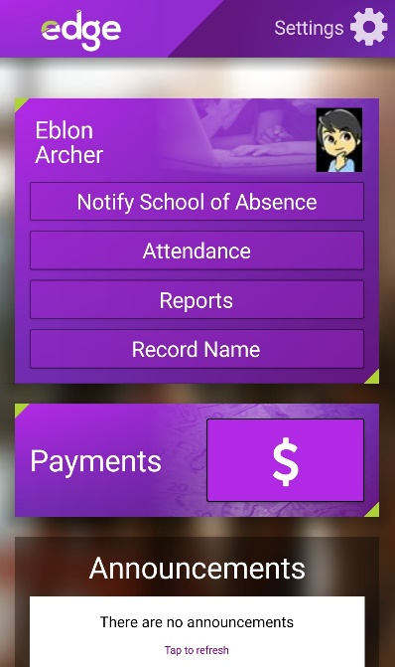
This can be downloaded from either Play Store (Android) or App Store (iOS). Search for musac edge.

Once installed you will be asked to make up a 4 digit pin then enter your Edge email and password.
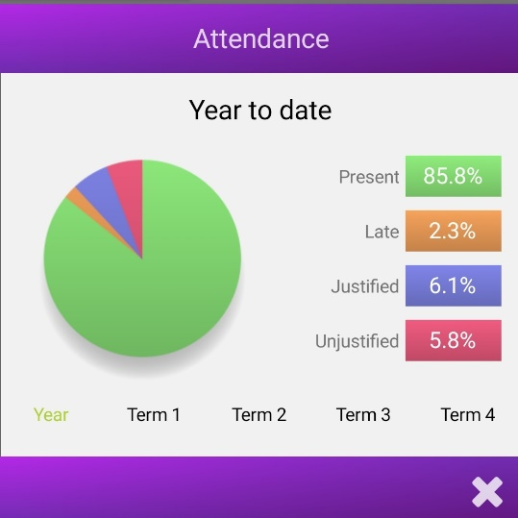
In the app there is a series of labelled tiles that when tapped bring up information on your child’s contact details, timetable, attendance, NCEA results and related data. Your school may also push announcements and notifications to the app and optionally allow you to send ‘Notify School of Absence’ notifications to the school.
After 3 minutes of non-use the Edge app will log out and require you to enter your 4 digit pin to re-open.

